Lab 01

# Objectives:

The purpose of the first lab of DBS211 is to familiarize yourself with the User Interface, SQL Developer, that we will be using throughout the course to communicate with the Oracle server. By the end of this lab you should be able to:

* Successfully establish a connection with and login to the Oracle database server using SQL Developer
* Run the sample database creation script
* Navigate SQL Developer to view the tables created, their structure and the data contained within them.

# LAB 01 - SUBMISSION

## Explore the Database

Answer the following questions in the SQL Developer Worksheet area. Use comment blocks for answers that are not running code.

In the connections window, expand **Tables.**

1. How many tables have been created? List the names of the created tables.

**Ans.** 8 tables are created. The name are as follows:

* CUSTOMERS
* EMPLOYEES
* OFFICES
* ORDERDETAILS
* ORDERS
* PAYMENTS
* PRODUCTLINES
* PRODUCTS

1. Click on table **customers**. Click on the Data tab near the top of the worksheet. How many rows are there in the table **customers**?

**Ans.** 122

1. What SQL statement would return the same results. Write the statement in the .sql file and execute it.

**Ans.** SELECT * FROM customers;

1. How many columns does the **customers** table have? List the column names.

**Ans.** 13. The names are as follows:

* CUSTOMERNUMBER
* CUSTOMERNAME
* CONTACTLASTNAME
* CONTACTFIRSTNAME
* PHONE
* ADDRESSLINE1
* ADDRESSLINE2
* CITY
* STATE
* POSTALCODE
* COUNTRY
* SALESREPEMPLOYEENUMBER
* CREDITLIMIT

1. What is the value of each column in the first row in table **customers**? Write the column name and the column data type in addition to the value.

**Ans.** CUSTOMERNUMBER: 103

CUSTOMERNAME: Atelier graphique

CONTACTLASTNAME: Schmitt

CONTACTFIRSTNAME: Carine

PHONE: 40.32.2555

ADDRESSLINE1: 54, rue Royale

ADDRESSLINE2: (null)

CITY: Nantes

STATE: (null)

POSTALCODE: 44000

COUNTRY: France

SALESREPEMPLOYEENUMBER: 1370

CREDITLIMIT: 21000

1. Write the number of rows and columns for the rest of the tables in your schema. Format it something like the following.

Table Name Rows Columns

EMPLOYEES 23 8

OFFICES 7 9

ORDERDETAILS 2996 5

ORDERS 326 7

PAYMENTS 273 4

PRODUCTLINES 7 4

PRODUCTS 110 9

Right Click on the **orderdetails** table and choose tables/count rows. How many rows does the order details table include?

**Ans.** 2996 ROWS

1. Write the following SQL statement in the new tab.

desc offices;

You can also write

describe offices;

What is the result of the statement execution?

**Ans.**  **Name** **Null? Type**

OFFICECODE NOT NULL VARCHAR2(10)

CITY NOT NULL VARCHAR2(50)

PHONE NOT NULL VARCHAR2(50)

ADDRESSLINE1 NOT NULL VARCHAR2(50)

ADDRESSLINE2 VARCHAR2(50)

STATE VARCHAR2(50)

COUNTRY NOT NULL VARCHAR2(50)

POSTALCODE NOT NULL VARCHAR2(15)

TERRITORY NOT NULL VARCHAR2(10)

1. Type the following statements in, execute them, then briefly describe what the statement is doing!

SELECT * FROM employees;

**It is shows all the data from the “employee” table**

SELECT * FROM customer ORDER BY ContactLastName;

**It shows all the data from the “customer” table, and orders it alphabetically according to the “contactlastname” column.**

1. How many constraints does the **products** table have?  
     
   **Ans.** It has 11 constraints.
2. 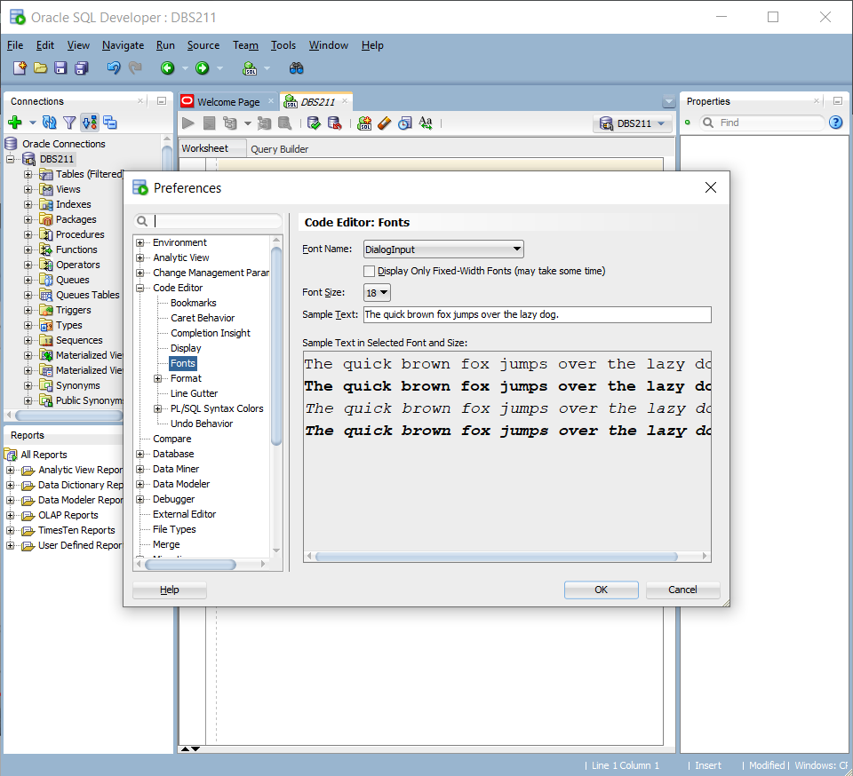Set the font size in the worksheet editor to a size that is best for you. (Hint: Tools/Preferences)